Master of Interior Architecture

REPORT

Table of contents
Table of contents 2
Mission and vision 3
Mission 3
Vision 3
Timeline 5
Vision-Innovation 6
Educational quality 6
Vision committee 6
Members of the vision committee 6
Findings 7
Notable features 7
Recommendations 7
Strategy 8

VISION ON ARCHITECTURAL EDUCATION
The dynamics, diversity and complexity of society are ever increasing (affordability, climate, super-diversity, ...). We also see this in our own working field and our student population. We therefore endorse with our programme the international movements within the field such as the 'New European Bauhaus movement' that strives for a future that is more sustainable, inclusive and beautiful; and the Davos Declaration on Baukultur that strives for an architectural practice that is qualitative and part of a cultural discourse (as a reaction to a purely technical approach to the discipline). Our programme also subscribes to Hasselt University's ambition to develop as a "civic university" (see Education Policy Plan UHasselt 2022-2029).

Therefore, we strive to educate critical designers; who can deal with uncertain and dynamic processes; who are willing to specialise and engage in lifelong learning; who are committed to their region but always with a focus to the rest of the world. Our bachelor programme forms the broad basis for this; the master allows a further profiling within four domains: furniture/living, scenography, retail design, reallocation (cfr. 'we give students roots in the bachelor, wings in the master').

Therefore, we choose this educational vision: 'the design studio as the core, fed by theoretical knowledge and research, within the region of Limburg in dialogue with the world'.

TIMELINE
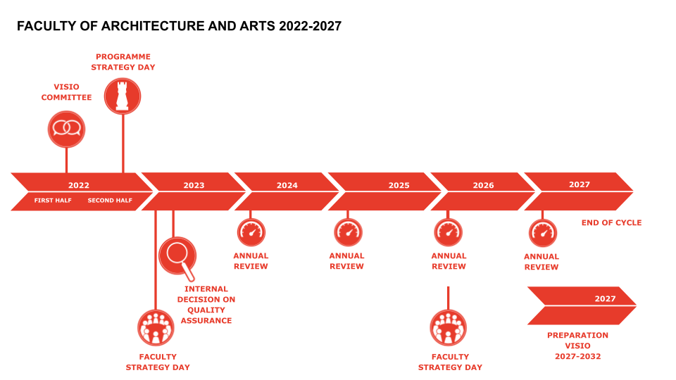

VISION-INNOVATION

Educational quality
The educational quality report provides an analysis of the programme’s educational quality. Staff members at the Quality Assurance Office conducted an analysis of the quality of education on the basis of the programme portfolio and data from quality assurance tools.
After the analysis had been finalised, the Quality Assurance Office and the Director of Education worked with the programme management to formulate suggestions and identify opportunities consistent with the university’s educational vision and objectives.
The educational quality report was presented to the education management team (EMT) on September 13, 2022, after which it was finalised. The final report was sent to the EMT, the vice rector for education and the dean, and has been added to the programme portfolio. The report forms an integral part of the strategic plan, which is submitted to the Board of Governors.
The education quality report reflects quality characteristics derived from the quality assurance system and the Standards and Guidelines for Quality Assurance in the European Higher Education Area.
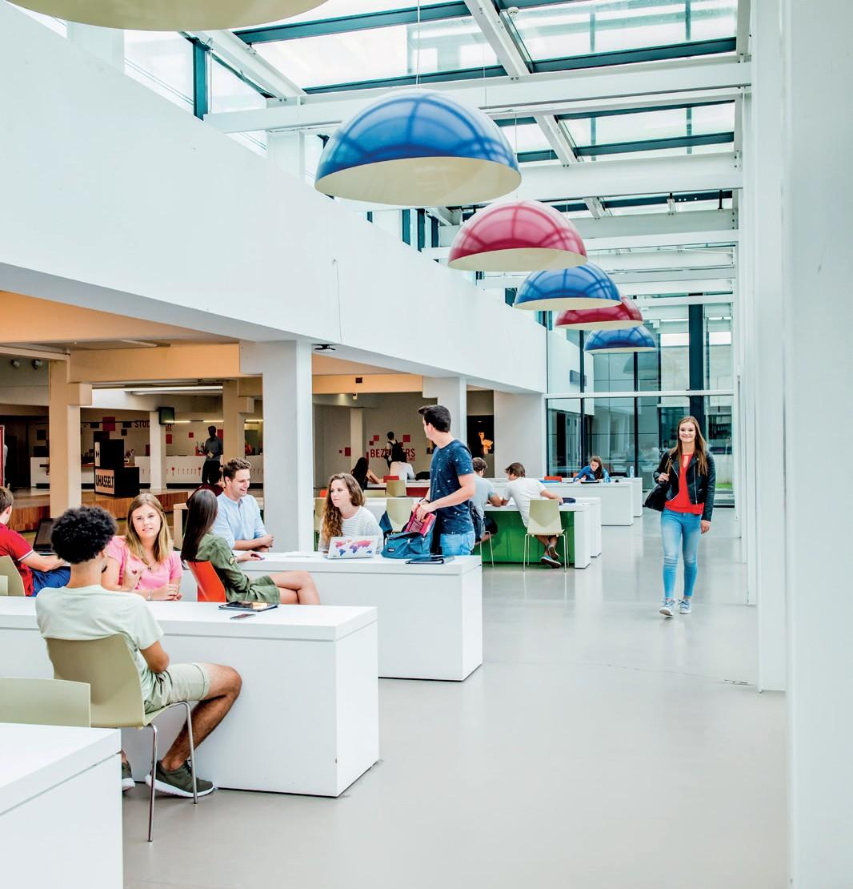

Vision committee
The vision committee focuses on the programme’s educational vision or visionary aspect. The committee focuses on the programme’s academic level and the up-to-dateness of its content. The committee makes no judgement about the quality of the programme’s educational aspects.
The members of the vision committee engage in friendly but critical dialogue, based on a variety of perspectives, with the EMT and various programme stakeholders. At its meeting of June 23, 2022, the vision committee analysed the approach taken and the vision for the future of the bachelor's and master's programmes in interior architecture on the basis of the documents provided and a site visit. The committee held discussions with:
- the EMT, which explained the current curriculum
- alumni and representatives of the professional field, who were asked about the extent to which the programme meets the requirements of the professional field
- students, who discussed their experiences in the programme.
In this way, the committee was able to form a broad picture of the programme, its qualities and its challenges.

Members of the vision committee
Substantive expert, chair:
- Prof.dr.ir. Klaske Havik, TU Delft

Peer:
- Prof.dr. Inge Somers, Antwerp University

Representative from professional field:
- Bea Geboers, POLO architects

Alumnus and/or student:
- Vincent Bergiers, alumnus

FINDINGS

Notable features
- The design of the programme through its studios gives a clear structure to the program. Students are given sufficient space and opportunities to follow their own interests within the curriculum through the studios.
- The interaction between research, education and design practice appears to be well established, partly due to collaboration of the various ZAP profiles (design and research lecturers). Clear examples of academic research can be found in the master's thesis and project, the internship, design assignments and the research seminar.
- The development of the university students' (academic) critical thinking (in addition to their practical skills), on which the programme places strong emphasis, is greatly appreciated. Professionals and alumni agree that when entering the field, students have a solid academic knowledge and technical skills that meet the requirements of a variety of roles as interior designers.
- The programme puts sufficient effort into providing a broad academic foundation which is kept up to date. Internships and contact with internship mentors and the broader professional field play an important role in staying up to date.
- The civic profiling is a strength of the program. The profiling of UHasselt as a civic university seems to be self-evident for the interior architecture programme, as the programme is strongly practice-oriented and requires a lot of contact with the field.
- The education is strongly tailored to the needs of the student with intensive supervision of students, low-threshold contact between students and teachers, close follow-up and (mid-term) feedback, and a good balance of didactic formats.

Recommendations
- The structure of the programme can be further clarified.
- Continuous attention to further aligning the intake of students with the required starting competencies is recommended. The programme must clearly present itself as an academic programme, so that it is clear to both students and the professional field what the difference in finality is compared to the more practically oriented programmes.
- The link between education, research and debate culture should be strengthened. The programme can put stronger emphasis on self-directed learning of students and on reflection on the learning process through the portfolio.
- It is recommended that the realism of the assignments and projects, in addition to the internship, be kept permanently high (including a diverse and inclusive mind). It is also recommended that the details and place of the internship in the programme be reviewed.
- Collaborations with different disciplines outside one's own faculty should be further elaborated to increase the multidisciplinarity of the programme.
- The rapid development of the professional field requires the continued stimulation of lifelong learning among students and alumni. It is recommended to have structural dialogue with various stakeholders (through focus discussions/questionnaires to students, alumni and the work field) in order to examine whether the acquired skills and fields of expertise meet current needs and are adequately developed in the curriculum.

strategy

Strategy day and plan
On October 24 and November 14, 2022, the strategy day for the bachelor’s and master’s programmes in interior architecture took place. The vice rector for education, the dean of the faculty, the EMT’s chair and members and staff members for education and from the Educational Development, Diversity and Innovation Office and the Quality Assurance Office took part in this day. The strategic plan was approved by the Board of Governors on May 11th, 2023.

Strategic plan objectives

- we start SD 1 by setting the conditions for implementing the strategy plan and securing the current quality in the curriculum;
- in SD 2 we formulate the attitude from which we start;
- in SD 3 we go into the methodology by which we want to shape this attitude;
- in SD 4 we focus on the debate to provide input for this methodology;
- in SD 5 we work on the knowledge and skills this requires from students.
SD 1 MONITOR PRECONDITIONS TO WORK ON THE EDUCATION STRATEGY PLAN AND SECURING AND APPRECIATING THE CURRENT QUALITY OF OUR EDUCATION/CURRICULUM.
- Monitoring staff workload and monitoring student workload
- Monitoring (organisational) coherence of the curriculum
- Monitor mutual involvement of teachers and involvement in the entire program given e.g. smaller assignments, interaction between 2 campuses ...
- Development of infrastructure that strengthens education and optimization of use of buildings Begijnhof and Diepenbeek
- Integration of the education strategy plan with the research & valorisation plan and internationalisation plan
SD 2 COMMITMENT TO MANUFACTURABILITY AND REALISM
- Strengthen civic activities in the programme
- (continue to) focus on real assignments and attention to manufacturability
- Strengthen cooperation with the region and the professional field, and further expand an (international) network
SD 3 FURTHER DEVELOPMENT OF THE INTERACTION BETWEEN EDUCATION-RESEARCH (DESIGN) PRACTICE
- Evaluate and reflect on current interaction between education, research and (design) practice
- Strengthen the interaction between research lines, seminars and design studios
SD 4 INTENSIFYING THE (INTERNAL) DEBATE CULTURE
- Conduct debate around questions arising from the research lines and themes design studios
- Building a context for exchange (internal and external)
SD 5 STRENGTHEN THE BROAD EMPLOYABILITY OF DESIGNERS / COMPETENCE-BASED EDUCATION
- Strengthening the self regulation of students
- Strengthen the employability of designers by focusing on competency-based education ((visual) language skills (also English), sustainability competencies, analytical skills, world citizenship...)
- Stronger alignment of intake with the profile of the program

DOCUMENTS
- Full VISIO report (available internally)
- Programme brochure Faculty of Architecture and Art

