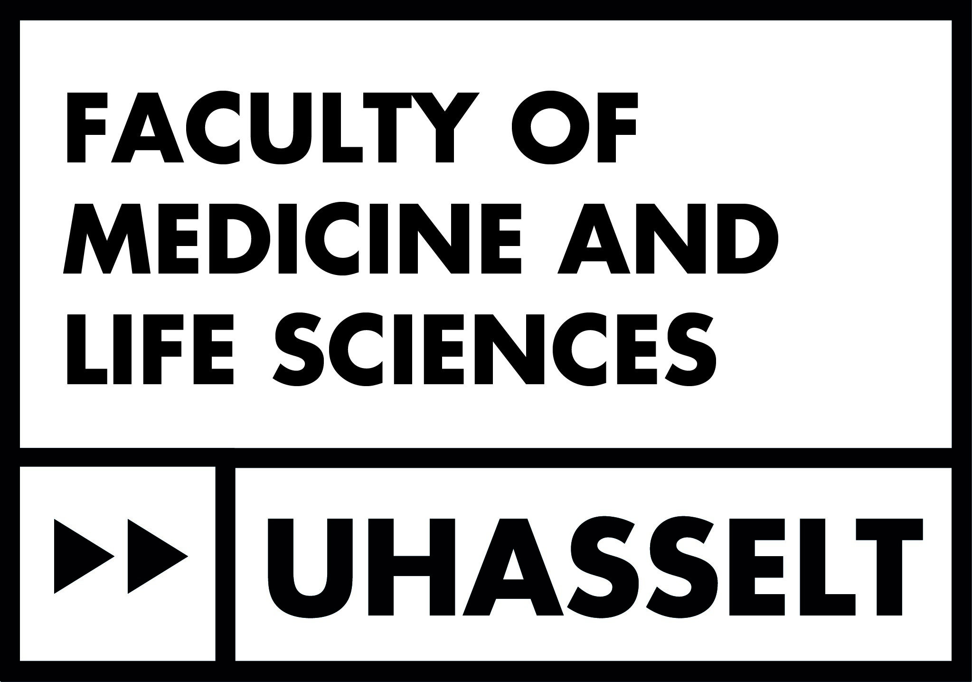

Required documents for the submission to the Ethics Committee UHasselt

* Submission letter
* Application form
* Protocol
* Protocol synopsis
* Subject Informed Consent (Dutch)
* Subject Informed consent (English/French) if applicable
* GDPR Checklist (save the completed checklist (inbox gmail) as pdf and add to file)
* Patient documents/questionnaires (Dutch)
* recruitment materials
* Investigator’s Brochure*
* ‘Technische Fiche’ needed for the insurance application
* Insurance certificate ( in case the sponsor is an external company or organisation)
* Agreement(s) such as e.g. CTA (Clinical Trial Agreement), MTA (material transfer), Service Agreement,...***
* Agreements with other services (if applicable)
* CVs of all researchers involved in the study
* GCP certificate of all investigators involved in the study **
* European Clinical Trial Application Form*
* Receipt of confirmation EudraCT number*
* List of the participating Belgian sites and ethics committees

* Only for commercial clinical studies

** A free GCP certificate can be obtained from the website via [this link](https://globalhealthtrainingcentre.tghn.org/ich-good-clinical-practice/)

*** An agreement is necessary when other universities, institutes or companies are involved in the study. Please contact the TTO UHasselt.

**Contact details CME UHasselt**

**Chairman**

Prof. dr. Ivo Lambrichts

Universiteit Hasselt – Campus Diepenbeek

Agoralaan gebouw C

3590 Diepenbeek

Tel: 011 26 92 45

Ivo.lambrichts@uhasselt.be

**Contact**

Marleen Missotten

CME@uhasselt.be

+32 11 26 85 02